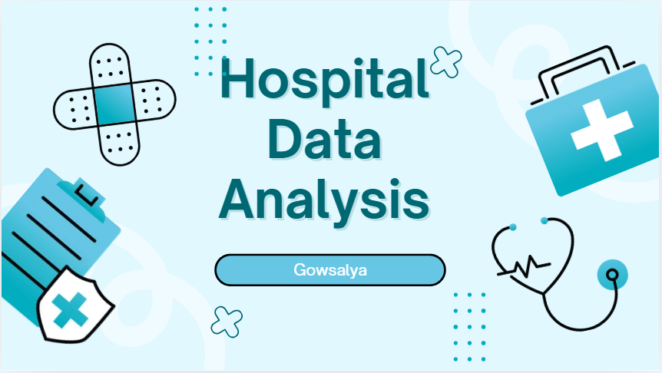
Project Overview and Objective:
The Hospital Data Analysis project aims to analyse patient records to identify healthcare trends, treatment outcomes, hospital costs, and patient satisfaction. The project transforms raw hospital data into meaningful insights using Microsoft Excel for data preprocessing and Microsoft Power BI for interactive dashboards and business intelligence reporting.
Objectives
- Analyse patient demographics.
- Evaluate treatment costs across different medical conditions.
- Monitor average hospital stay.
- Identify patient readmission total.
- Measure treatment outcomes.
- Analyse patient satisfaction levels.
- Build an interactive Power BI dashboard.
- Generate actionable insights for hospital management.
Data Sources:
- The data used in this project consists of two datasets: a raw dataset in CSV format and a cleaned dataset in Microsoft Excel format. The raw dataset contains the original patient records collected from a hospital information system
- The cleaned dataset served as the primary source for analysis and dashboard development in Microsoft Power BI, ensuring that the visualizations were based on accurate and reliable data.
Problem Statement:
Hospitals generate large volumes of patient data daily. Without proper analysis, valuable information related to treatment costs, patient outcomes, hospital stay, and satisfaction remains underutilized. The primary challenge is to transform raw patient records into meaningful business intelligence that supports hospital administrators in making informed decisions. This project addresses that challenge by cleaning, analysing, and visualizing hospital data to uncover trends and performance indicators.
Attributes:
Attribute Name | Data Type | Description
Patient ID | Text | Unique identifier assigned to each patient
Age | Integer | Patient age in years
Gender | Text | Gender of the patient
Condition | Text | Medical condition diagnosed
Procedure | Text | Treatment or medical procedure performed
Cost | Decimal | Total treatment cost
Length of Stay | Integer | Number of days admitted
Readmission | Text | Indicates whether the patient was readmitted
Outcome | Text | Final treatment result (Recovered, Improved, etc.)
Satisfaction | Integer | Patient satisfaction score
Cost Per Day | Decimal | Treatment cost divided by length of stay
Tools and Technologies:
- Tool | Purpose
- Microsoft Excel | Data cleaning and preprocessing
- Power BI Desktop | Dashboard development and visualization
- Power Query | Data transformation
- DAX | Creating calculated columns and measures
- Pivot Tables | Data summarization
- Charts | Trend analysis
Data Preprocessing:
Data preprocessing was performed using Microsoft Excel to improve the quality and reliability of the dataset before analysis. The raw CSV dataset was first imported into Excel, where it was carefully examined for missing values, duplicate records, inconsistent formatting, and data validation issues. Since no missing or duplicate records were identified, the dataset was validated to ensure consistency across all attributes. Filtering and sorting features were used to organize patient records based on age, gender, medical conditions, treatment costs, and hospital stay duration, making the data easier to review and analyse. Pivot Tables were then created to summarize patient information, compare treatment outcomes, analyse costs across different medical conditions, and evaluate condition wise minimum length of stay. Additionally, a new calculated column named Cost Per Day was created by dividing the total treatment cost by the length of hospital stay, providing an additional performance metric for further analysis in Power BI.
Data Modeling and DAX (Power BI):
- The cleaned dataset was imported into Microsoft Power BI, where a simple data model was developed to support interactive analysis. Since the project utilizes a single cleaned dataset, no table relationships were required within the data model. Power Query was used to verify the data structure and ensure that each attribute was assigned the appropriate data type before loading the data into the model.
- DAX (Data Analysis Expressions) was used to create calculated measures such as Total Patients, Total Treatment Cost, Average Treatment Cost, Average Length of Stay, Average Patient Satisfaction, Female Patients and Male Patients. These measures enabled dynamic calculations that automatically update based on user selections through filters and slicers, providing flexible and interactive analysis within the dashboard.
Analysis and Visualization (Power BI):
Microsoft Power BI was used to create an interactive dashboard that presents hospital patient data through a variety of visualizations. KPI cards were used to display important metrics such as the total number of patients, total treatment cost, total readmission, average treatment cost, average hospital stay, and average patient satisfaction. Bar charts and column charts were developed to compare patient counts, treatment costs, and medical procedures across different categories. Donut charts illustrate the distribution of patient outcome. Interactive slicers were included to allow users to filter the dashboard by gender, medical condition, making it easier to perform detailed analysis and explore different aspects of hospital performance. These visualizations transform raw data into meaningful information that supports effective decision-making and healthcare management.
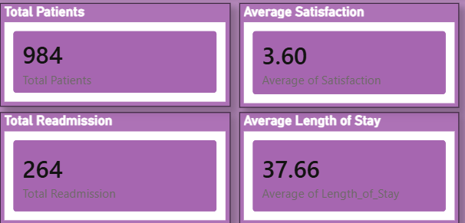
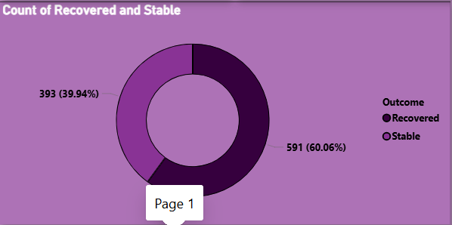

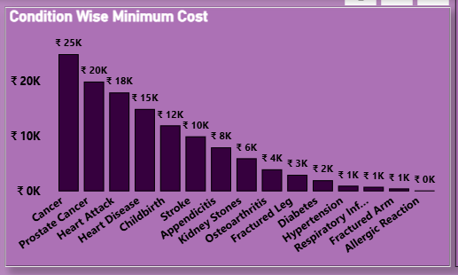
Key Findings:
The healthcare dashboard provides a comprehensive overview of patient and treatment data using a combination of key performance indicators (KPIs), charts, and interactive filters. KPI cards display important metrics, including the total number of patients, total treatment cost, average treatment cost, average length of stay, average patient satisfaction, and total readmissions, allowing users to monitor overall healthcare performance at a glance. A column chart visualizes the distribution of total patients by age group and compares condition-wise treatment costs, helping identify the most affected age groups and the conditions associated with higher expenses. A donut chart illustrates the distribution of patients by treatment outcome, making it easy to assess recovery and other outcomes. A line chart shows the total number of patients across different medical conditions, enabling trend comparison among conditions. A bar chart presents the minimum cost per day for various medical procedures, highlighting the least expensive procedures on a daily basis. To enhance interactivity, slicers for gender and medical condition allow users to filter the dashboard dynamically, enabling detailed analysis and supporting data-driven decision-making.
Conclusion:
The Hospital Data Analysis project successfully transformed raw patient records into meaningful business intelligence through Excel and Power BI. Data preprocessing ensured the dataset was accurate, complete, and suitable for analysis. Interactive dashboards enabled the visualization of patient demographics, treatment costs, hospital stay duration, readmission patterns, treatment outcomes, and satisfaction levels. The insights generated from this analysis can help hospital administrators optimize resource allocation, improve patient care, reduce readmission rates, and make informed strategic decisions. Overall, the project demonstrates how data analytics can support evidence-based healthcare management and enhance operational efficiency.

